

**DEPARTMENT OF INFORMATION TECHNOLOGY**

***Synopsis of Mini Project On***

Stock Analysis Using Deep Learning

Prepared By:

Omkar A Ghogale (Roll No. 7)

Rohit B Ghongade (Roll No. 8 )

Manish M Madeshia (Roll No. 21 )

Under the guidance of: Mr. Saurabh Suman

**Department of Information Technology**

**Academic Year: 2021-22**

**SEM IV (SE - IT)**

**SHREE L.R TIWARI OF ENGINEERING,**

**KANKIA PARK, NEAR COMMISSIONER BUNGALOW,MIRA ROAD (E)**

**MUMBAI - 401107.**

### DEPARTMENT OF INFORMATION TECHNOLOGY

**CERTIFICATE**

## This is to certify that following students:

Sr. No. Name of Student Roll No. / Seat No.

1. Omkar A Ghogale 07

2. Rohit B Ghongade 08

3. Manish M Madeshia 21

have submitted Mini-Project Report on *“Stock Analysis Using Deep Learning”* as the partial fulfillment for the requirement of Second Year of Engineering (4th Semester) in B.E. - Information Technology under my guidance during the academic year 2021-22.

|  |  |
| --- | --- |
| **Mr. Saurabh Suman** | **Dr. Roopali Lolage** |
| **Project Guide** | **Head of Department** |
| **Assistant Professor** | **Professor** |
| **Department of Information Technology** | **Department of Information Technology** |

**Date of Examination: _________________**

**Signature of Internal Examiner Signature of External Examiner**

**Table of Contents**

|  |  |
| --- | --- |
| CHAPTER 1: INTRODUCTION   * 1. Motivation   2. Objective | …6  …7 |
| CHAPTER 2: REVIEW OF RELATED LITERATURE  2.1 Related Work | …8  …10 |
| CHAPTER 3: FUNCTIONALITIES OF PROPOSED SYSTEM  3.1 Functionalities  3.2 Flow diagram | …11  …12 |
| CHAPTER 4: CONCLUSION AND FUTURE PLAN OF WORK  4.1 Conclusion  4.2 Future plan of work | …13 |
| CHAPTER 5: REFERENCES | …14 |

**List of Tables**

|  |  |
| --- | --- |
| 2.1 Comparative Study | …5 |

**List of Figures**

|  |  |
| --- | --- |
| 3.1 Overview of system | …7 |

## ACKNOWLEDGEMENT

A few sublime human experiences defy expressions of any kind, and a feeling of true gratitude is one of them. I, therefore, find words quite inadequate to express my indebtedness to my Guide **Prof. Saurabh Suman** for his virtuous guidance, encouragement and help throughout this work. Their deep insight into the problem and the ability to provide solutions has been of immense value in improving the quality of projects at all stages. This experience of working with them shall ever remain a source of inspiration and encouragement for me.

I express my thanks to **Dr. Roopali Lolage**, HOD (IT), SLRTCE, Mira Road, for extending his support that she gave truly helped the progression of the project work. I express my thanks to **Mrs. Reena Kothari**, Asst. Prof., SLRTCE, Mira Road for extending her support.

My sincere thanks to **Dr. S. Ram Reddy**, Principal, SLRTCE, Mira Road for providing me the necessary administrative assistance in the completion of the work.

I am extremely grateful to the celebrated authors whose precious works have been consulted and referred to in my project work. I also wish to convey my appreciation to my friends who provided encouragement and timely support in the hour of need.

Special thanks to my Parents whose love and affectionate blessings have been a constant source of inspiration in making this a reality.

All the thanks are, however, only a fraction of what is due to the Almighty for granting me an opportunity and the divine grace to successfully accomplish this assignment.

**Omkar A Ghogale**

**Rohit B Ghongade**

**Manish M Madeshia**

**Abstract**

Market predication software plays very important role in today’s digital world. In Stock Market Prediction, the aim is to predict the future value of the financial stocks of a company. The recent trend in stock market prediction technologies is the use of machine learning which makes predictions based on the values of current stock market indices by training on their previous values. Machine learning itself employs different models to make prediction easier and authentic. The paper focuses on the use of Regression and LSTM based Machine learning to predict stock values. Factors considered are open, close, low, high and volume. In a financially volatile market, as the stock market, it is important to have a very precise prediction of a future trend. Because of the financial crisis and scoring profits, it is mandatory to have a secure prediction of the values of the stocks. Predicting a non-linear signal requires advanced algorithms of machine learning. The system basically help in predicting the stock future with help of machine learning.

Keyword

**Chapter 1 : Introduction**

**Chapter 1: Introduction**

A stock market is a platform for trading of a company’s stocks and derivatives at an agreed price. Supply and demand of shares drive the stock market. In any country stock market is one of the most emerging sectors. Nowadays, many people are indirectly or directly related to this sector. Therefore, it becomes essential to know about market trends. Thus, with the development of the stock market, people are interested in forecasting stock price. But, due to dynamic nature and liable to quick changes in stock price, prediction of the stock price becomes a challenging task. Stock markets are mostly a non-parametric, non-linear, noisy and deterministic chaotic system

As the technology is increasing, stock traders are moving towards to use Intelligent Trading Systems rather than fundamental analysis for predicting prices of stocks, which helps them to take immediate investment decisions. One of the main aims of a trader is to predict the stock price such that he can sell it before its value decline, or buy the stock before the price rises. The efficient market hypothesis states that it is not possible to predict stock prices and that stock behaves in the random walk. It seems to be very difficult to replace the professionalism of an experienced trader for predicting the stock price. But because of the availability of a remarkable amount of data and technological advancements we can now formulate an appropriate algorithm for prediction whose results can increase the profits for traders or investment firms. Thus, the accuracy of an algorithm is directly proportional to gains made by using the algorithm.

* 1. **Motivation**

Motivation for the project are we student and new comers in stock market .While studying student also require some extra income so that they may not be reliable on their parents for their daily necessity by the project they can invest small amount of money without spending much time on research and this project is also help for the new comers in the market so that they have a good return without investing time on research .

* 1. **Objectives**
* Our main objective is to provide better predication of a stock using machine learning
* To provide a good return with less research.
* We will provide recommendation to user based on his search on the stock history
* We aim to provide better predications.

**Chapter 2 : Literature Review**

**Chapter 2: Literature Review**

* 1. **Related Work**

**Traditional Machine Learning Techniques**

The authors of studied the behavior of the stock market and determine the best fit model from the several traditional machine learning algorithms which included Random Forest (RF), Support Vector Machine (SVM), Naive Bayes, K-Nearest Neighbor (KNN), and Softmax for stock market prediction.The authors conducted a comparative study of these approaches, several technical indicators wereapplied to the data that was gathered from different data sources including Yahoo and NSE-India. The accuracy of each model was compared and it was observed that RF gave the most satisfying results for large datasets whereas for small datasets Naive Bayesian revealed the highest accuracy. Anotherobservation made was, as the count of technical indicators was reduced the accuracy of the models decreased.The paper used various TF-IDF features to forecast the prices of the stocks of the next day basedon the data that was gathered from different news channels. The authors computed TF-IDF weights tocount the word score. Finally, an HMM model was generated to calculate the probability of a sequenceand contained the probabilities of switching values. From this model the authors observed a trend of positive and negative predictions which were partially matching and showed an error of 0.2 to 4%,however increasing the size of the dataset, employing various machine learning algorithms or increasing the number of technical indicators and input features can lead to higher accuracy.Traditionally, only historical data was applied for forecasting share prices. However, analysts nowrecognize that relying purely on historical data isn't accurate because a lot of other factors are key todetermining the stock price. In the paper the authors study and apply different methods to predictstock prices but a high rate of accuracy is still not achieved even after analyzing major factors affectingthe stock price. The authors have reviewed major techniques such as SVM, Regression, Random Forest,etc. and also analyzed hybrid models by combining two or more techniques. According to the authors,some models work better with historical data than with sentiment data. Fusion algorithms yielded resultswith higher predictions.

**Time Series Analysis**

The paper “Share Price Prediction using Machine Learning Technique” represented the stock price in the form of a time series and avoided the complications endured by the model in the training process. The paper used normalised data and a Recurrent Neural Network model for making the predictions that predicted values that were very close to the actual ones and thus, the author’s considered machine learning algorithms best for forecasting the stock prices. The authors of noticed an impact of daily sentiment scores of various companies on the values of their stock prices. As the information or news that gets posted on various social media platforms about/by an organisation can influence the investors to buy/sell the stocks of the company thus affecting its stock value. The authors thus proposed a model for stock market prediction that employed sentimental analysis as one of the indicators. The algorithm made use of data collected from various online platforms such as Yahoo Finance and positive/negative/neutral tweets as features for the prediction and computed the stock price movement using opening and closing price of stock for the respective company. Another interesting aspect noted by the authors was the effect of holidays, seasonality, trends and non-periodic data and designed a curve time series model which took all these components into account. This culminated in the authors employing the Generalised Additive Model for maximizing prediction quality and to accommodate newcomponents. Finally, Multiple Linear Regression was used to train the model and predict the prices of stocks for the next 10 days.

**Deep Learning and neural networks**

Deep Learning is a subset of Machine Learning, which on the other hand is a subset of Artificial Intelligence. Artificial Intelligence is a general term that refers to techniques that enable computers to mimic human behavior. Machine Learning represents a set of algorithms trained on data that make all of this possible. Deep Learning, on the other hand, is just a type of Machine Learning, inspired by the structure of a human brain. Deep learning algorithms attempt to draw similar conclusions as humans would by continually analyzing data with a given logical structure. To achieve this, deep learning uses a multi-layered structure of algorithms called neural networks. The design of the neural network is based on the structure of the human brain. Just as we use our brains to identify patterns and classify different types of information, neural networks can be taught to perform the same tasks on data.

The individual layers of neural networks can also be thought of as a sort of filter that works from gross to subtle, increasing the likelihood of detecting and outputting a correct result.

The human brain works similarly. Whenever we receive new information, the brain tries to compare it with known objects. The same concept is also used by deep neural networks.

Neural networks enable us to perform many tasks, such as clustering, classification or regression. With neural networks, we can group or sort unlabeled data according to similarities among the samples in this data. Or in the case of classification, we can train the network on a labeled dataset in order to classify the samples in this dataset into different categories.

In general, neural networks can perform the same tasks as classical algorithms of machine learning. However, it is not the other way around.

Artificial neural networks have unique capabilities that enable deep learning models to solve tasks that machine learning models can never solve.

All recent advances in artificial intelligence in recent years are due to deep learning. Without deep learning, we would not have self-driving cars, chatbots or personal assistants like Alexa and Siri. The Google Translate app would continue to be as primitive as 10 years ago (before Google switched to neural networks for this App), and Netflix or Youtube would have no idea which movies or TV series we like or dislike. Behind all these technologies are neural networks.

**A systematic review of fundamental and technical analysis of stock market predictions**

In the stock market, the investor shows interest in profit by investing some money in the stock market. The stock market has shows investor interest due to advanced applications where prediction may lead to prosperous market forecasting. Predicting movements [15] of the stock market precisely depends on advance information. The tools which are used for stock market forecasting [16,17] can track and control the market which can be used to make the right decisions. The stock market needs to handle several information [18] on industrial stocks which covers the entire financial market. These are adjusted according to the business status investors [19–21] who consider sales and purchase. Several factors affect the market position are the future estimation income, a news release on earnings and changes in management, etc. Therefore, accurate prediction [22] of the stock market helps investors in making better decisions. Through ML techniques the investor can earn more money with high risk. Fig. 1 describes the process of the stock market. In Fig. 1, firstly real-time data is collected from various sources either websites or previous datasets such as NASDAQ [23] based on their price index. The price index is a subset of the stock market and it grants investors to compare the current price flatten with past market prices for performance calculation. After collecting data, the collected data is preprocessed [24] for removing the noise and other parameters. Then preprocessed data can be useful for stock market forecasting. The feature selection methods select some features [25] from a huge amount of data. Some of the data analyzer function or user-friendly application divides the dataset into two subcategories namely as current and prediction details. These details are very useful for making better stock market decisions. After a strong decision, a notification [26,27] is sent to investors about the prices index. This notification is very useful for investors because this notification [28] tells the status of profit or loss for price index. If the status generated by the application [29] is profit, then the investor can use the shares for high sales and if the prices index is low [30] then development is more attention to make better decisions.

**Time series prediction and neural networks**

The standard neural network method of performing time series prediction is to induce the function f using any feedforward function approximating neural network architecture, such as, a standard MLP, an RBF architecture, or a Cascade correlation model [5], using a set of N-tuples as inputs and a single output as the target value of the network. This method is often called the sliding window technique as the N-tuple input slides over the full training set. Figure 1 gives the basic architecture.

**Long short-term memory, Neural computation, vol. 9**

Compared to traditional neural network, recurrent neural network (RNN) has internal memory, they memorize all information stored in the past and use it to make decisions in further step. Even RNNs work well when dealing with short sequence data, they suffer from two major problems: gradient vanishing and gradient exploding. To solve the problems of RNN, Long Short-Term Memory (LSTM) could be considered. LSTM works as a specific RNN with the improvement on identifying long-term dependency in sequence data. Different from RNNs, LSTMs perform a more complex way in computing the hidden state with replacing the traditional hidden layer neurons by sets of memory cell.

**Stock Price Prediction Based on LSTM Neural Network**

Stock market is full of uncertainty and influenced by various factors, like macroeconomic policy, the performance of company and public sentiment. Due to the characteristics of high-volatile and noise, it is difficult to apply some traditional statistical models into financial time series prediction with high precision [10], Some studies show that some machine learning method, like recurrent neural networks, could be successfully used to forecast time series [11], As one specific case of RNN model, LSTM has unique memory selection mechanism. It stores useful memory and discard unsuitable information by using its memory cells, which could effectively capture the structure of data over long period with high accuracy. Therefore, this paper considers LSTM as a good choice to predict stock price.

**Indian Stock Market Prediction using Deep Learning**

LSTM network, which is suitable for learning temporal patterns, is extensively utilized for various tasks of time-series analyses [7]. LSTM is preferred over the conventional RNN as it overcomes the problem of vanishing (or exploding) gradients and as it can effectively learn longterm dependencies through memory cells and gates. Thus, many studies on financial time-series modeling are conducted using LSTMs LSTM can be trained to learn dependencies ranging over very long time intervals of time. It beats the vanishing gradients problem faced by a general RNN by substituting the ordinary neuron by a complex architecture called the LSTM unit or block

**Chapter 3: Functionalities of Proposed System**

**Chapter 3: Functionalities of Proposed System**

**3.1 Functionalities**

The system provides a good interface for display of stocks and their predictions

It provides Prediction of Stocks in graphically manner

It provides fast reliable prediction of stocks

It provides prediction for commodities, indexes and all financial instruments available on yahoo finance website

**3.2 Flow Diagram**

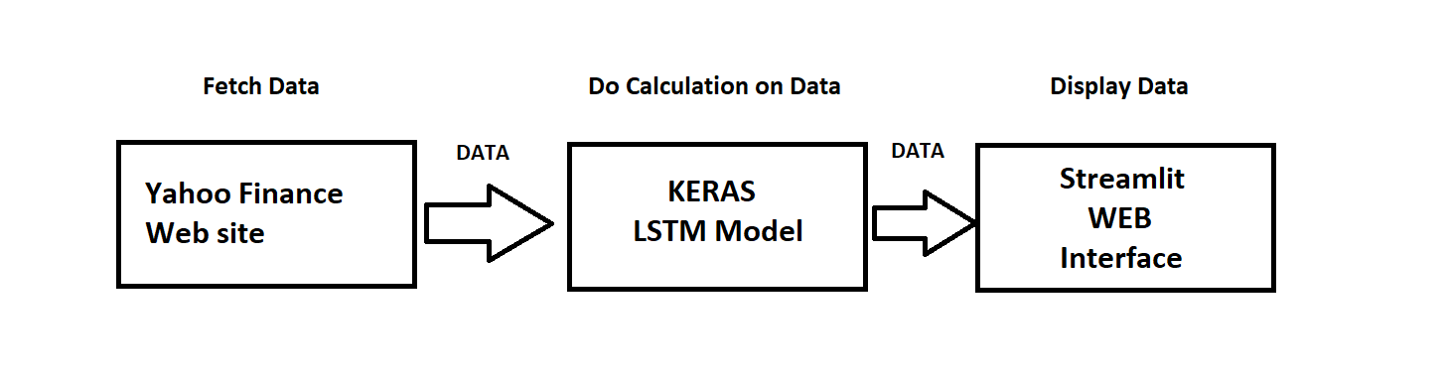

**Program Code**

**Module 1:Lstm Model For Predicition**

import numpy as np

import pandas as pd

import matplotlib.pyplot as plt

import pandas_datareader as data

start ='2010-01-01'

end ='2019-12-31'

df=data.DataReader('AAPL','yahoo',start,end)

df =df.reset_index()

df=df.drop(['Date','Adj Close'],axis=1)

ma100=df.Close.rolling(100).mean()

ma200=df.Close.rolling(200).mean()

data_training=pd.DataFrame(df['Close'][0:int(len(df)*0.70)])

data_testing=pd.DataFrame(df['Close'][int(len(df)*0.70):int(len(df))])

from sklearn.preprocessing import MinMaxScaler

scaler=MinMaxScaler(feature_range=(0,1))

data_training_array=scaler.fit_transform(data_training)

data_training_array

x_train=[]

y_train=[]

for i in range (100,data_training_array.shape[0]):

x_train.append(data_training_array[i-100:i])

y_train.append(data_training_array[i,0])

x_train,y_train=np.array(x_train), np.array(y_train)

from keras.layers import Dense,Dropout,LSTM

from keras.models import Sequential

model=Sequential()

model.add(LSTM(units=50,activation='relu',return_sequences=True,

input_shape=(x_train.shape[1],1)))

model.add(Dropout(0.2))

model.add(LSTM(units=60,activation='relu',return_sequences=True))

model.add(Dropout(0.3))

model.add(LSTM(units=80,activation='relu',return_sequences=True))

model.add(Dropout(0.4))

**Module 2 : Code For Displaying Interface of Project On Localhoast**

import numpy as np

from datetime import date

import pandas as pd

import matplotlib.pyplot as plt

import pandas_datareader as data

from keras.models import load_model

import streamlit as st

start ='2012-01-01'

end =date.today().strftime("%Y-%m-%d")

st.title('Market Predicitor')

user_input=st.text_input('Stock Ticker','ICICIBANK.NS')

df=data.DataReader(user_input,'yahoo',start,end)

st.subheader('Data')

st.write(df.describe())

st.subheader('Closing Price')

fig=plt.figure(figsize=(12,6))

plt.plot(df.Close,label='Closing Price')

plt.legend()

st.pyplot(fig)

st.subheader('Closing Price With 100 Days Moving Average')

ma100= df.Close.rolling(100).mean()

fig=plt.figure(figsize=(12,6))

plt.plot(ma100,label='100 Days MAVG')

plt.plot(df.Close,label='Closing Price')

plt.legend()

st.pyplot(fig)

st.subheader('Closing Price With 200 and 100 Days Moving Average')

ma100= df.Close.rolling(100).mean()

ma200= df.Close.rolling(200).mean()

fig=plt.figure(figsize=(12,6))

plt.plot(ma100,label='100 Days MAVG')

plt.plot(ma200,label='200 Days MAVG')

plt.plot(df.Close)

plt.legend()

st.pyplot(fig)

data_training=pd.DataFrame(df['Close'][0:int(len(df)*0.70)])

data_testing=pd.DataFrame(df['Close'][int(len(df)*0.70):int(len(df))])

from sklearn.preprocessing import MinMaxScaler

scaler=MinMaxScaler(feature_range=(0,1))

data_training_array=scaler.fit_transform(data_training)

model= load_model('keras_model.h5')

past_100_days=data_training.tail(100)

final_df =past_100_days.append(data_testing,ignore_index=True)

input_data=scaler.fit_transform(final_df)

x_test=[]

y_test=[]

for i in range (100,input_data.shape[0]):

x_test.append(input_data[i-100:i])

y_test.append(input_data[i,0])

x_test ,y_test = np.array(x_test),np.array(y_test)

y_predicated=model.predict(x_test)

scaler=scaler.scale_

scale_factor=1/scaler[0]

y_predicated=y_predicated*scale_factor

y_test=y_test*scale_factor

st.subheader('Prediction')

fig2=plt.figure(figsize=(12,6))

plt.plot(y_test, 'b', label='Original Price')

plt.plot(y_predicated, 'r', label='Predicated price')

plt.legend()

st.pyplot(fig2)

**Chapter 4 : Output**

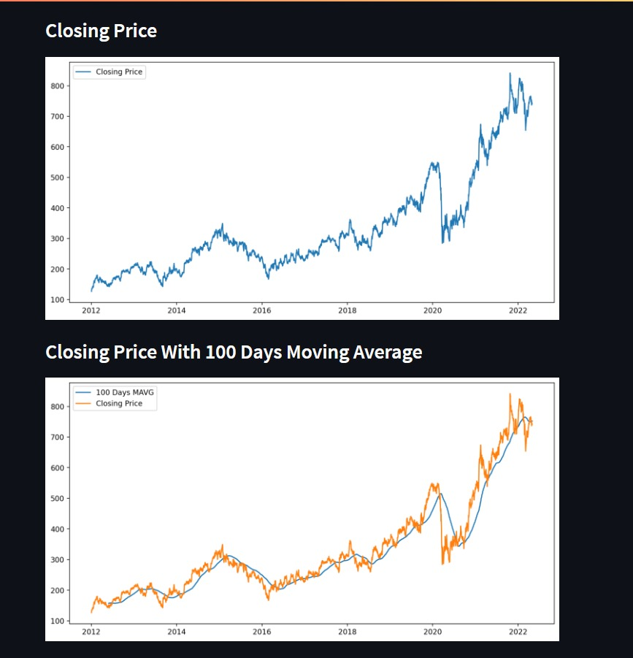

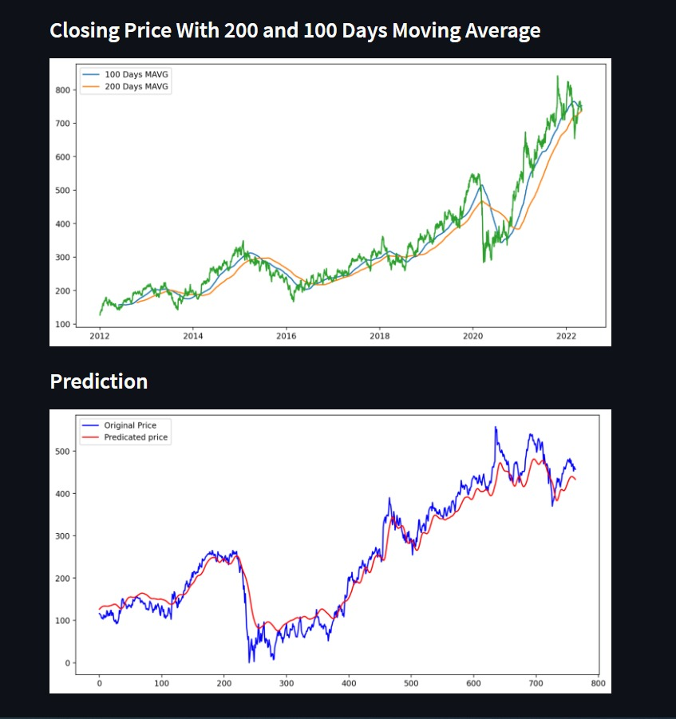

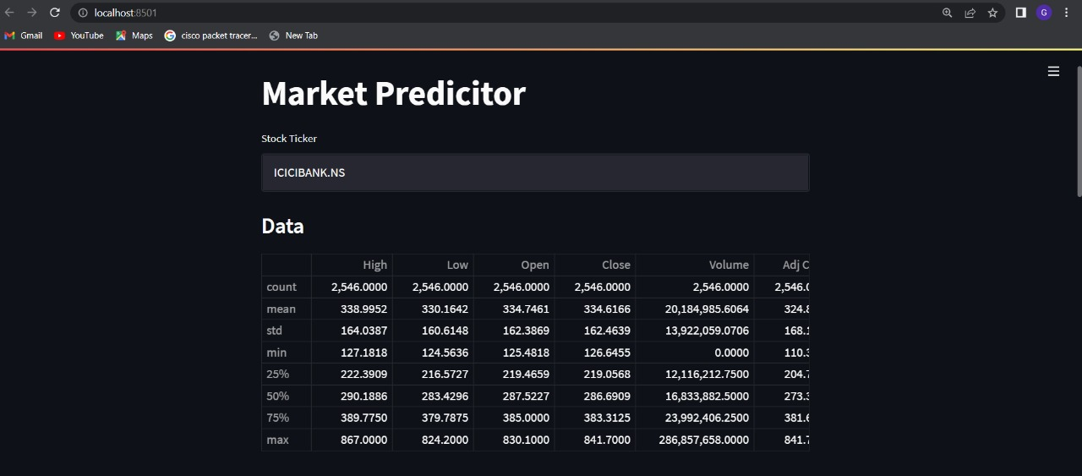

**Chapter 5 : System Requirement**

**Chapter 5 : : System Requirement**

1. Processor : i3 and above
2. System : Should have python3 installed
3. Python packages:
4. Numpy
5. Mathplotlib
6. Tensorflow
7. Keras
8. Streamlit
9. Panddas
10. Pandas Datareader
11. Sckit.learn

**Chapter 6: Conclusion and Future Plan of Work**

**Chapter 6: Conclusion and Future Plan of Work**

**4.1 Conclusion:**

In our above project we did the prediction using deep learning .Streamlit was used for displaying the predictions and charts of stocks .Python libraries like numpy , pandas ,pandas datareader, Sklearn tensor floe ,keras , matplotlib. The main model for predicting the stock price was made with keras a dense model was used for doing that .for pre processing the data sklearn numpy was used for reading data pandas datareader was used .Matplotlib was used for displaying the graphs with all the above libraries and deep learning model we successfully carried out predication of stock , commodities etc.

**4.2 Future Plan of Work:**

* Making System available for a large number of users
* Adding more parameters for predicating stocks
* Reducing reliability on Yahoo finance for Data
* Creating a local database of stock data so that the data maybe fetched faster
* Reducing the loss of the model for better prediction

**Chapter 7 : References**

**Chapter 7: References**

[1] I. K. Nti, A. F. Adekoya, and B. A. Weyori, “A systematic review of fundamental and technical analysis of stock market predictions,”Artificial Intelligence Review, pp. 1–51, 2019.

[2] R. J. Frank, N. Davey, and S. P. Hunt, “Time series prediction and neural networks,” Journal of intelligent and robotic systems, vol. 31, no. 1-3, pp. 91–103, 2001.

[3] S. Hochreiter and J. Schmidhuber, “Long short-term memory,” Neural computation, vol. 9, no. 8, pp. 1735–1780, 1997.

[4] Yuqiao Guo University of Illinois at Urbana-Champaign Champaign, IL, US, 61820 “ Stock Price Prediction Based on LSTM Neural Network ”,“Yuqiao Guo University of Illinois at Urbana-Champaig” 978-1-7281-9144-7/20,pp.1020-1024

[5] Pushparaj Shetty D, Ayan Maiti,”Indian Stock Market Prediction using Deep Learning” ,2020 IEEE REGION 10 CONFERENCE (TENCON) Osaka, Japan, November 16-19, 2020, 978-1-7281-8455-5/20,pp.1215-1220